Submitting to Online Repositories

In this section, we will generate a PRIDE XML file from the previously used human dataset. Load the example project into PeptideShaker:

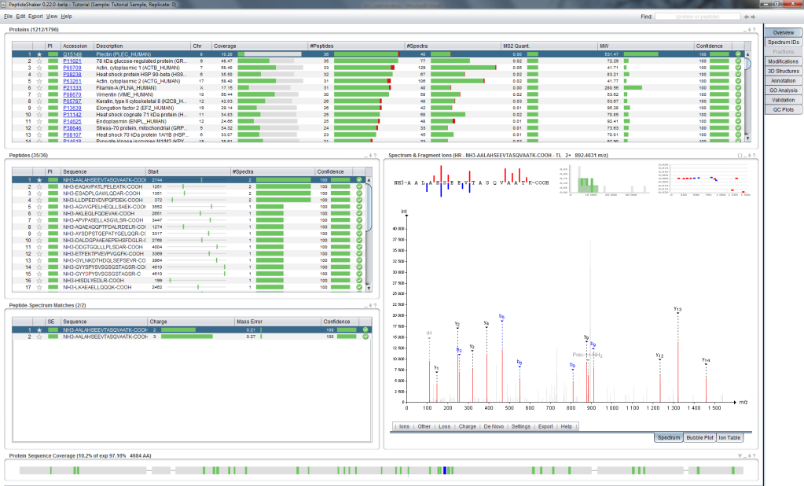

Now click on ‘Save As...’ in the ‘File’ menu and select ‘Export to PRIDE’. The following dialog appears:

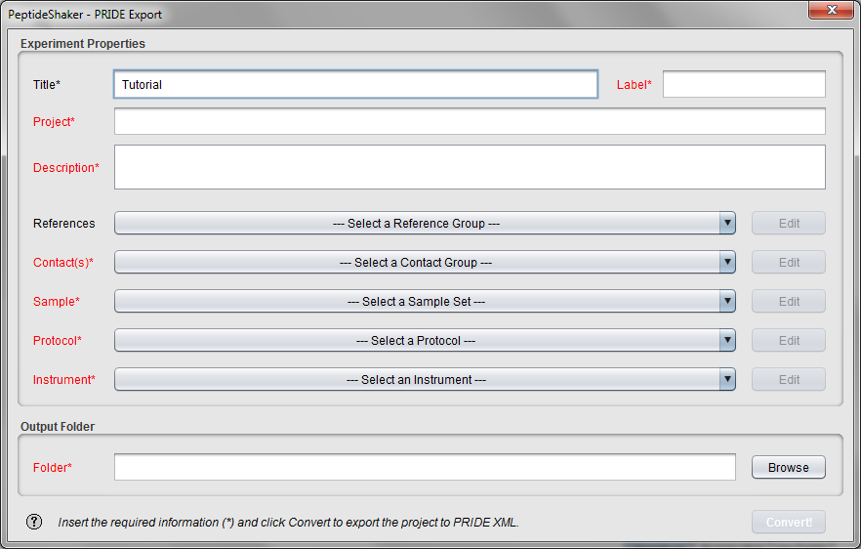

The information needed here will be used to annotate your dataset in PRIDE. Using the respective fields, create or select a Contact, a Sample, a Protocol and an Instrument for our dataset. Note that all terms are standardized, creating a HeLa Sample as detailed below will thus help other scientists working with HeLa cells to find your results.

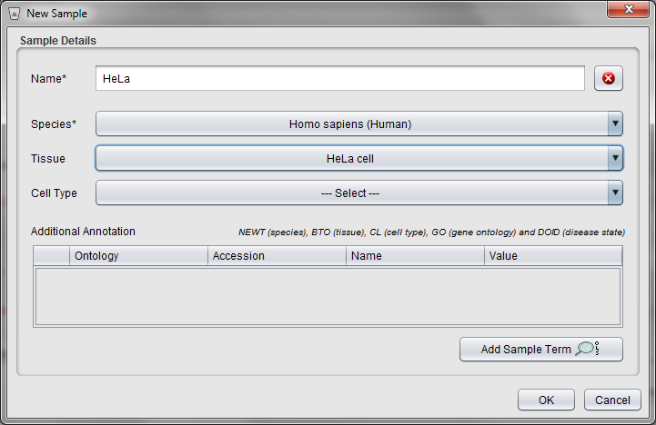

Selecting an output folder and clicking on the 'Convert!' button will start the creation of the PRIDE XML file. In order to save time, the corresponding file has already been generated for you and is located in the resources folder.

Start the ProteomeXchange submission tool located in the software folder (PX_Submission). (The tool can also be downloaded or launched directly from <http://www.proteomexchange.org>.)

You should now see the following screen:

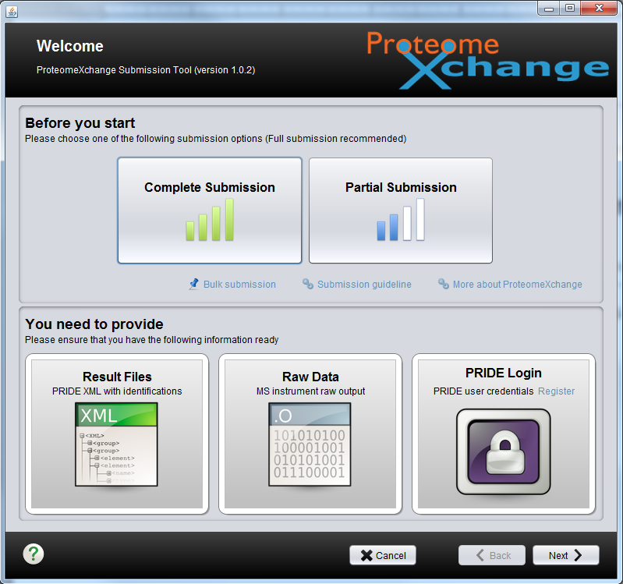

Click on ‘Complete Submission’ then ‘Next’. You will see the following screen:

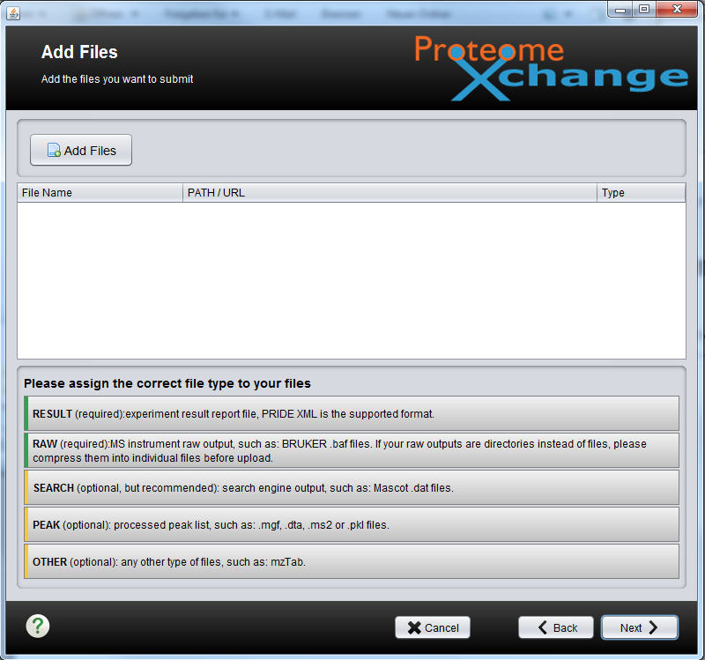

Here, load the raw file, the PRIDE XML file, the search result files (from OMSSA and X!Tandem) and the peak list. All these files are located in the resources folder. Note that the submission tool recognizes the different file formats, except for the X!Tandem result file.

In the last step, we will indicate that all the intermediate files led to the same PRIDE XML result. Add a relation between all files to the PRIDE XML file.

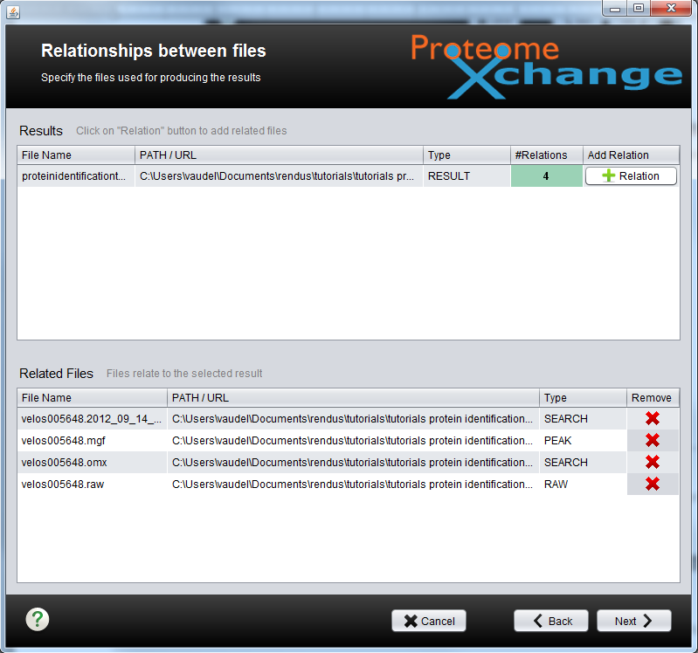

*In which case will you have different PRIDE XML files with different relations? [3.1a]*

In the next and final step, you will reference your experiment and upload it in PRIDE.

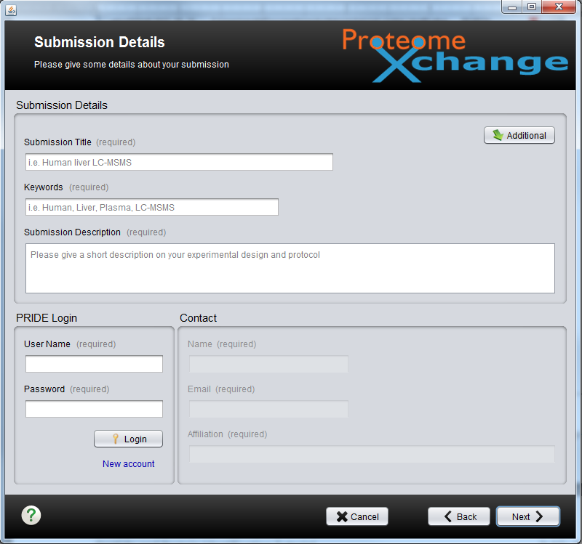

In order to upload a file, you need a PRIDE login which the PRIDE team will provide you on demand. Your dataset will stay private during the review process and a reviewer account will be established so that a reviewer can access your data. The credentials for these accounts should be made available in your manuscript. Once your paper is accepted, the data will be made freely available.

Obviously we will not upload the tutorial data online, however, if we had done this, all identification results will be available and can be browsed as demonstrated in the following chapters.

References